====INTERACTIVE MODE====

While trying to enter number of players if you type letters instead of numbers the program asks you to input again until you put numbers

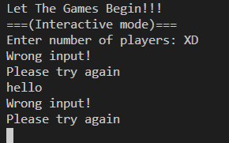

If you input number of amazons as letters instead of numbers the program will say its error invalid input, ask user to restart the program and exit the program

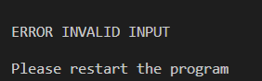

The same thing happens when the program asks for coordinates from user and the user types letters. On the other hand when the user enters value bigger than 9 or less than 0 it asks the user to input a number between 0 and 9.

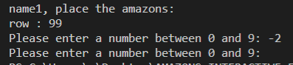

When the user inputs coordinates of an occupied place program asks user to input another coordinates.

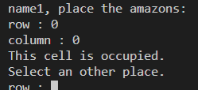

If you try moving an amazon that has blocked movement it will tell you that it’s blocked

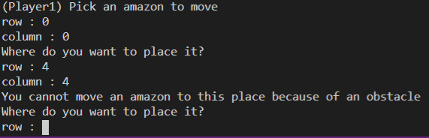

If the amazon is completely blocked it will notify you about it:

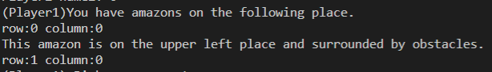

Checking shooting:

With arrow:

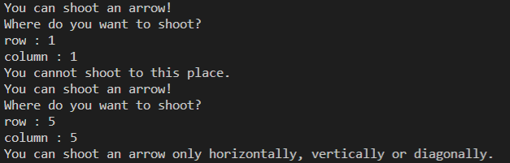

With spear either the shooting is not horizontally, vertically or diagonally or it’s blocked:

